**Course Code: ITA0447**

**Course Title: STATISTICS WITH R PROGRAMMING FOR NLP**

**LAB DAY : 01**

1. Write a R program to take input from the user (name and age) and display the values. Also print the version of R installation.

CODE:

name <- readline(prompt = "Enter your name: ")

age <- as.integer(readline(prompt = "Enter your age: "))

cat("Your name is", name, "and your age is", age, "\n")

cat("R version", paste(R.version$major, R.version$minor, R.version$patch, sep = "."), "\n")

OUTPUT:

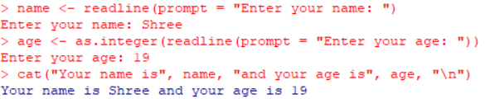

1. Write a R program to get the details of the objects in memory.

CODE:

x <- 1:10

y <- rnorm(100)

z <- "Hello World"

data <- data.frame(A = 1:5, B = c("a", "b", "c", "d", "e"))

obj.names <- ls()

for (obj.name in obj.names) {

obj.size <- object.size(get(obj.name))

cat(paste("Object name:", obj.name, "Object size:", obj.size, "\n"))

}

OUTPUT:

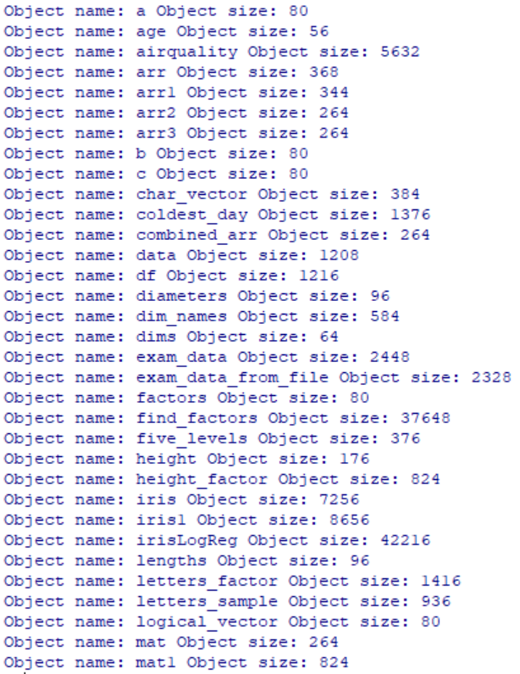

1. Write a R program to create a sequence of numbers from 20 to 50 and find the mean of numbers from 20 to 60 and sum of numbers from 51 to 91.

CODE:

seq1 <- 20:50

seq2 <- 20:60

mean1 <- mean(seq2)

seq3 <- 51:91

sum1 <- sum(seq3)

cat("Sequence 1: ", seq1, "\n")

cat("Mean of sequence 2: ", mean1, "\n")

cat("Sum of sequence 3: ", sum1, "\n")

OUTPUT:

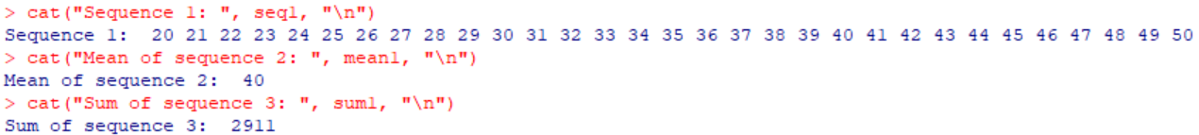

1. Write a R program to create a vector which contains 10 random integer values between -50 and +50.

CODE:

set.seed(123)

rand_vec <- sample(-50:50, 10, replace = TRUE)

cat("Random Vector: ", rand_vec, "\n")

OUTPUT:



1. Write a R program to get the first 10 Fibonacci numbers.

CODE:

fib <- function(n) {

if (n <= 1) {

return(n)

} else {

return(fib(n-1) + fib(n-2))

}

}

fib_seq <- numeric(10)

for (i in 1:10) {

fib_seq[i] <- fib(i)

}

cat("The first 10 Fibonacci numbers are: ", fib_seq, "\n")

OUTPUT:



1. Write a R program to get all prime numbers up to a given number (based on the sieve of Eratosthenes).

CODE:

sieve_of_eratosthenes <- function(n) {

nums <- 2:n

for (i in 2:sqrt(n)) {

nums <- nums[nums == i | nums %% i != 0]

}

return(nums)

}

n <- 50

primes <- sieve_of_eratosthenes(n)

cat("All prime numbers up to", n, "are:", primes, "\n")

OUTPUT:



1. Write a R program to print the numbers from 1 to 100 and print "Fizz" for multiples of 3, print "Buzz" for multiples of 5, and print "FizzBuzz" for multiples of both.

CODE:

for (i in 1:100) {

if (i %% 3 == 0 & i %% 5 == 0) {

cat("FizzBuzz\n")

} else if (i %% 3 == 0) {

cat("Fizz\n")

} else if (i %% 5 == 0) {

cat("Buzz\n")

} else {

cat(i, "\n")

}

}

OUTPUT:

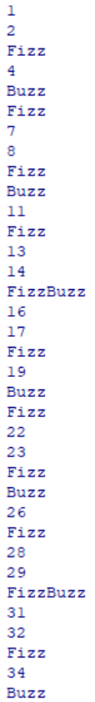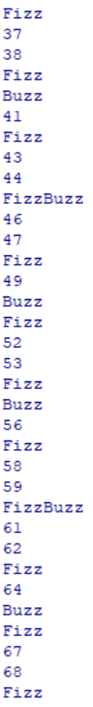

1. Write a R program to extract first 10 english letter in lower case and last 10 letters in upper case and extract letters between 22nd to 24th letters in upper case.

CODE:

first_letters <- letters[1:10]

cat("First 10 letters in lower case: ", first_letters, "\n")

last_letters <- toupper(letters[17:26])

cat("Last 10 letters in upper case: ", last_letters, "\n")

mid_letters <- toupper(letters[22:24])

cat("Letters between 22nd and 24th letters in upper case: ", mid_letters, "\n")

OUTPUT:

